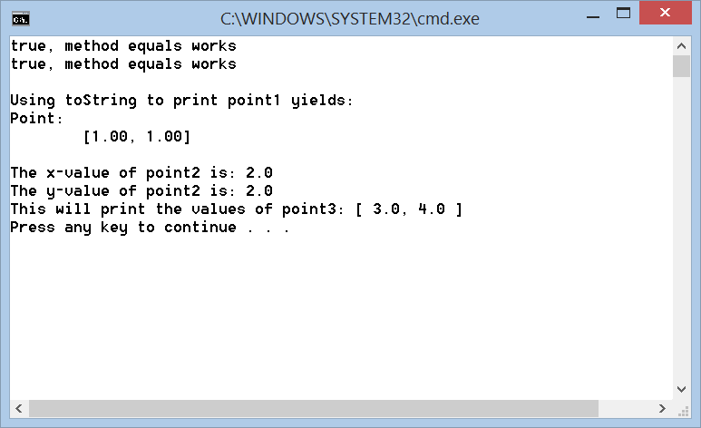**TestPoint.java compilation through textpad**

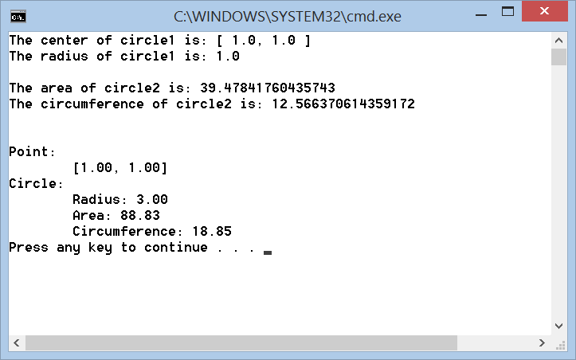**TestCircle.java compilation through textpad**

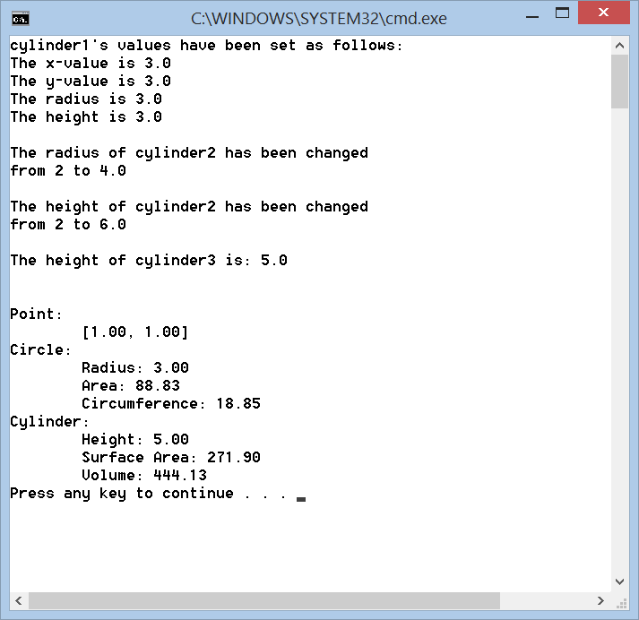**TestCylinder.java compilation through textpad**